**ROTC in the Age of COVID**

Morgan State University: Left Picture – Students prepare for Combat Survival Swim Training. Right Picture: PMS Major Morgan presents an award and an Officers Guide (courtesy of the Star Spangled Chapter) to new 2LT Sunday.

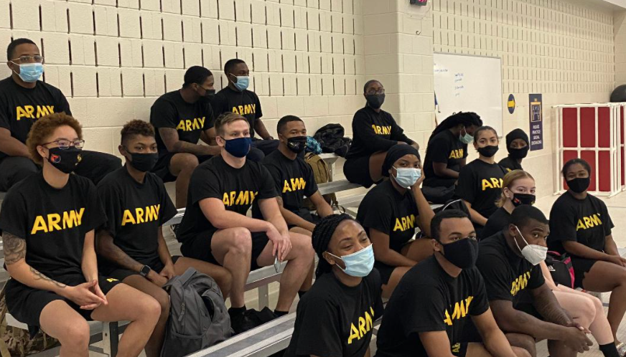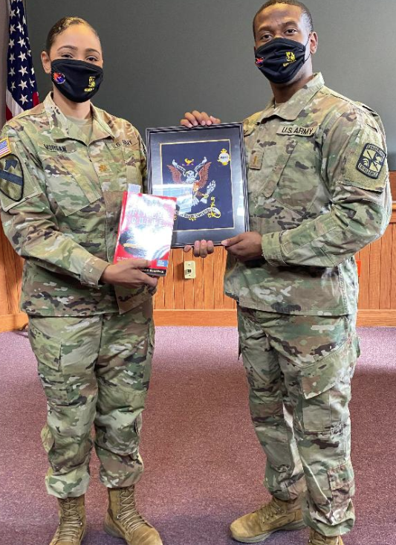

Left: Cadets at Johns Hopkins University on their Fall Field Exercise

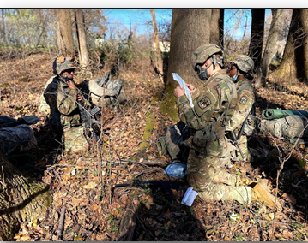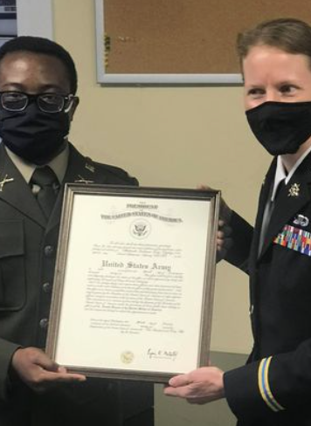

Right: LTC Oliva presents Army Commission to new 2LT Tony at Loyola University in January